# Social Media Marketing Dashboard

## Introduction

**Title**: KFC Campaign Performance Dashboard

**Purpose**: Provide Insights on Marketing campaign by KFC

**Audience**: KFC Managers, Stakeholders

## 2.0 Dashboard Overview

### 2.0.1 Tableau Dashboard

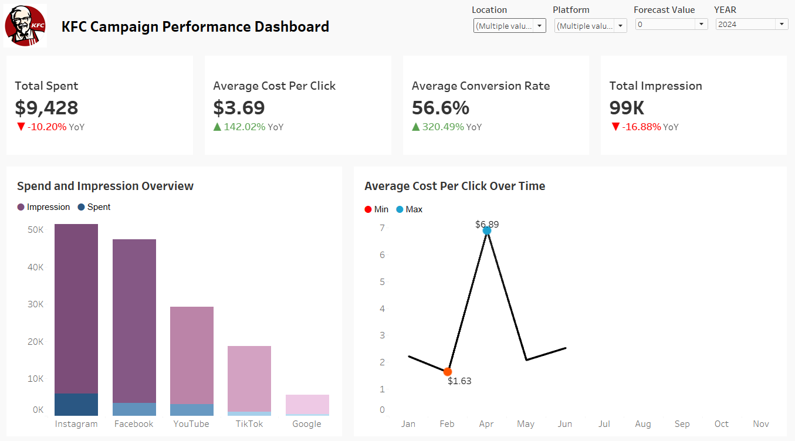

### 2.0.2 PowerBI Dashboard

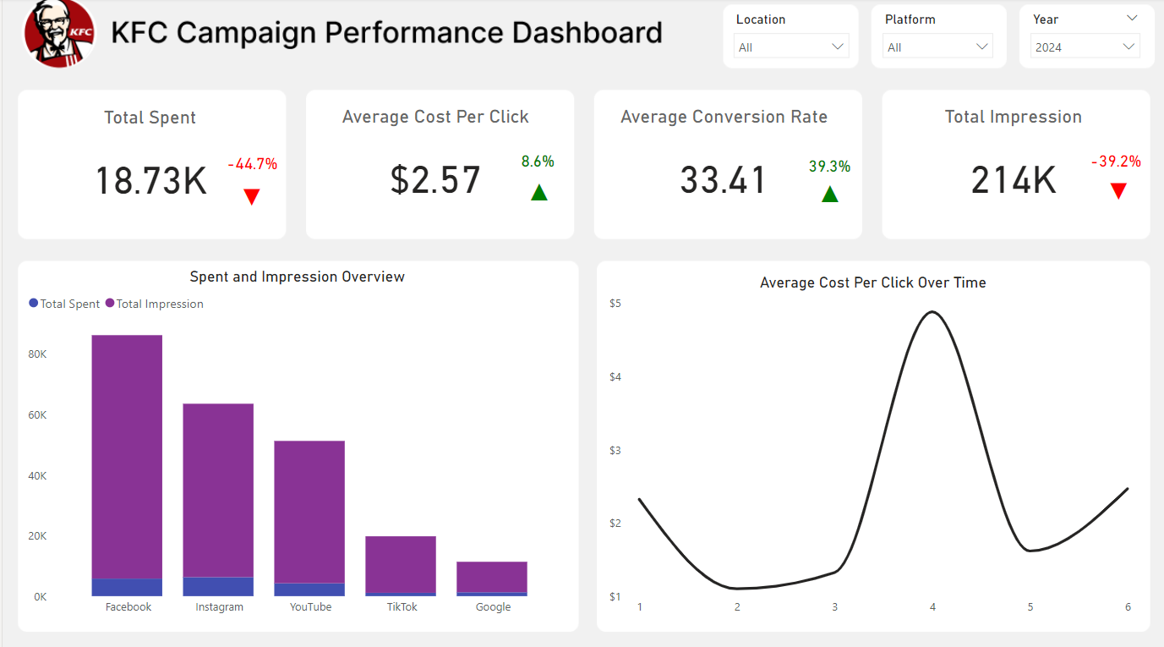

## 3.0 Data Sources

**Origin**: SQL Server with fact and dimension tables

## 4.0 Data Fields and Calculations

For Tableau and Power BI datafields are same.

**Tables Description:**

### Fact_camp

1. Date
2. Location_id
3. Platform_id
4. Ads_run
5. Impressions
6. Clicks
7. Conversions
8. Total_spent
9. Cost_per_click
10. Click_through_rate
11. Conversion_rate
12. Cost_per_conversion

### 2.0 dim_product

1. Platform_id
2. Platform

### 3.0 dim_location

1. Location_id
2. Location

### 4.0 dim_date

1. Date
2. Weekday
3. Day
4. Month
5. Year

### 4.0.1 Tableau Calculations

1. **KPI Total Spent**

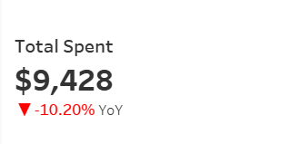

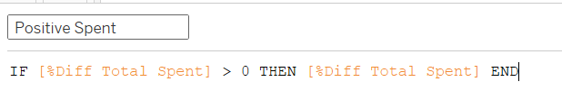

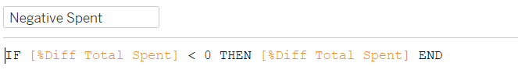

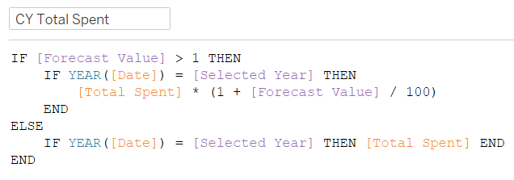

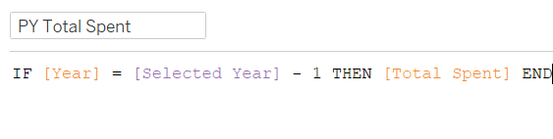

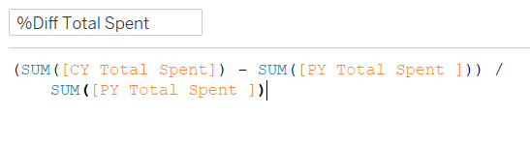

1. **KPI Avg Cost Per Click**

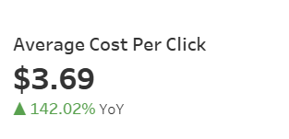

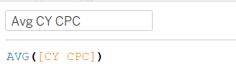

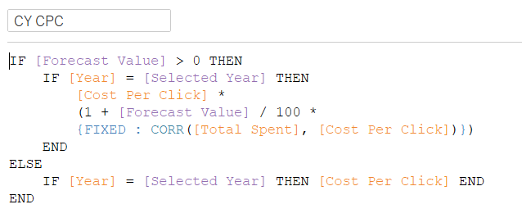

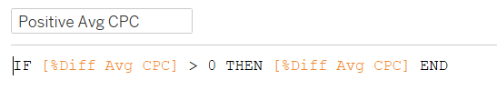

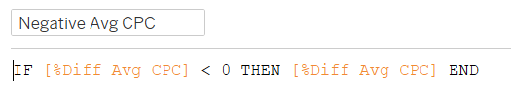

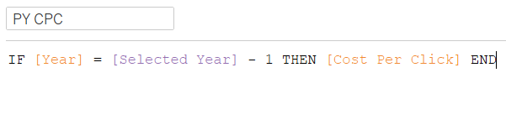

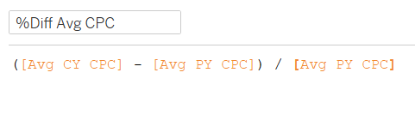

1. **KPI Conversion Rate**

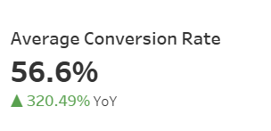

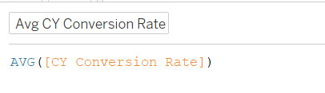

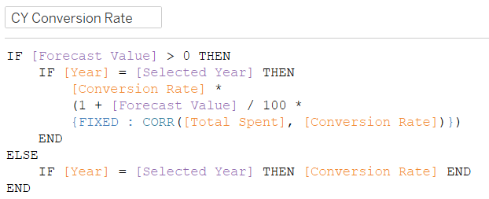

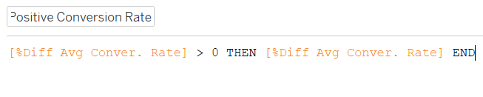

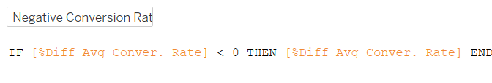

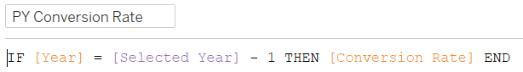

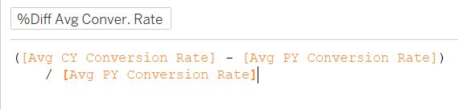

1. **KPI Total Impression**

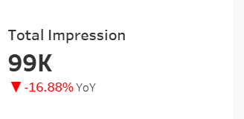

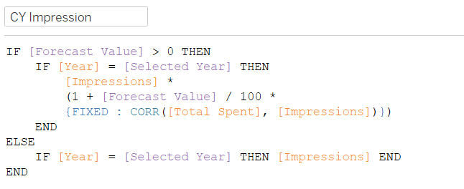

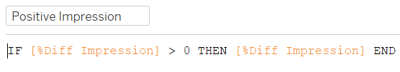

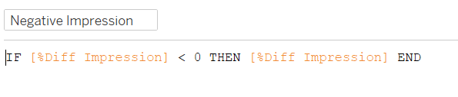

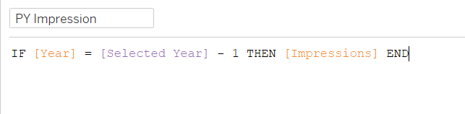

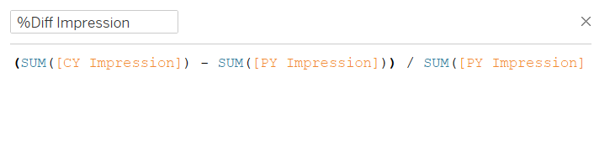

1. Avg CPC Line Chart

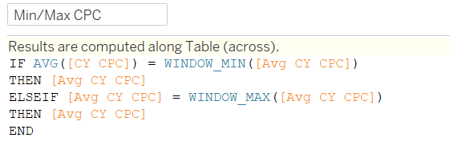

### 4.0.2 Power BI Measures

I’m only keeping in docs for one kpi as its too long

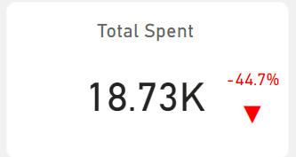



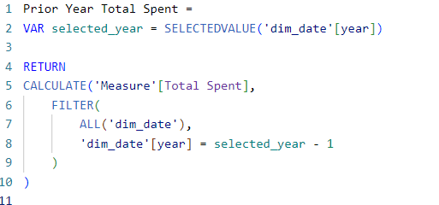



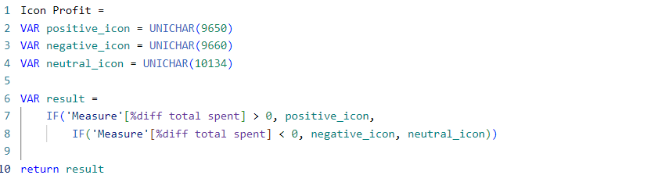



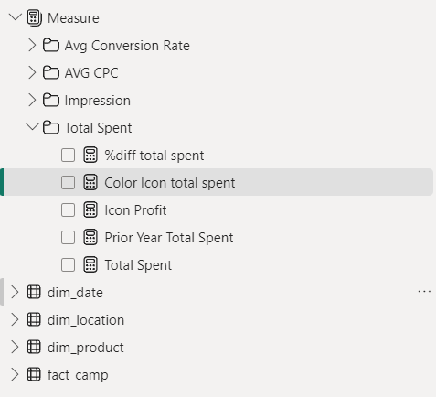

**LESSON – NEVER KEEP STORAGE MODE TO MIXED**

## SQL Validations

**NOTE: In tableau in filters**

1. ***Location filter*** *(Bhaktapur, Kathmandu is only selected)*
2. ***Platform Filter*** *(Facebook, Instagram is only selected)*

1. Total Spent KPI (doesn’t include YoY)

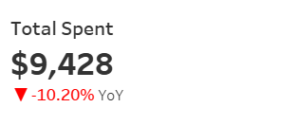

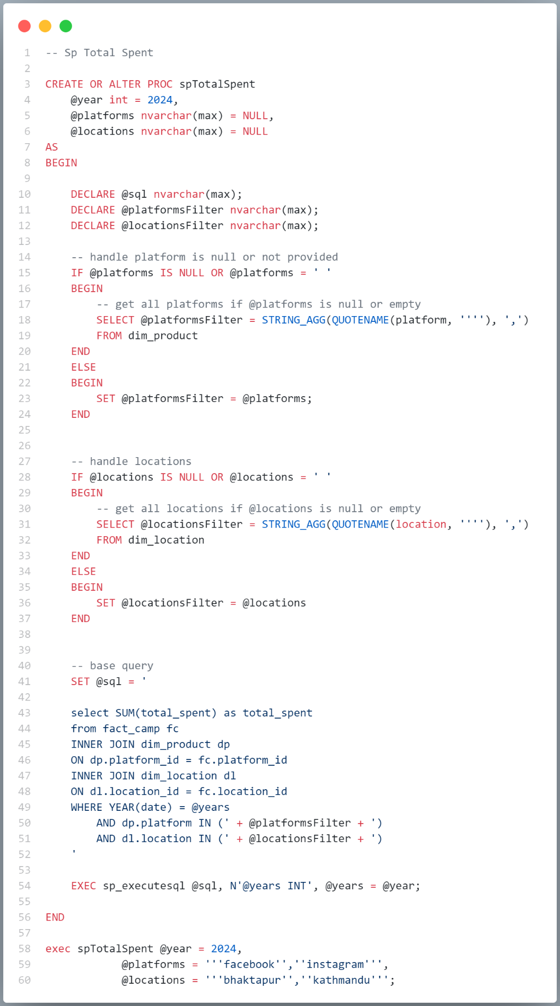



KPI Total Spent YoY

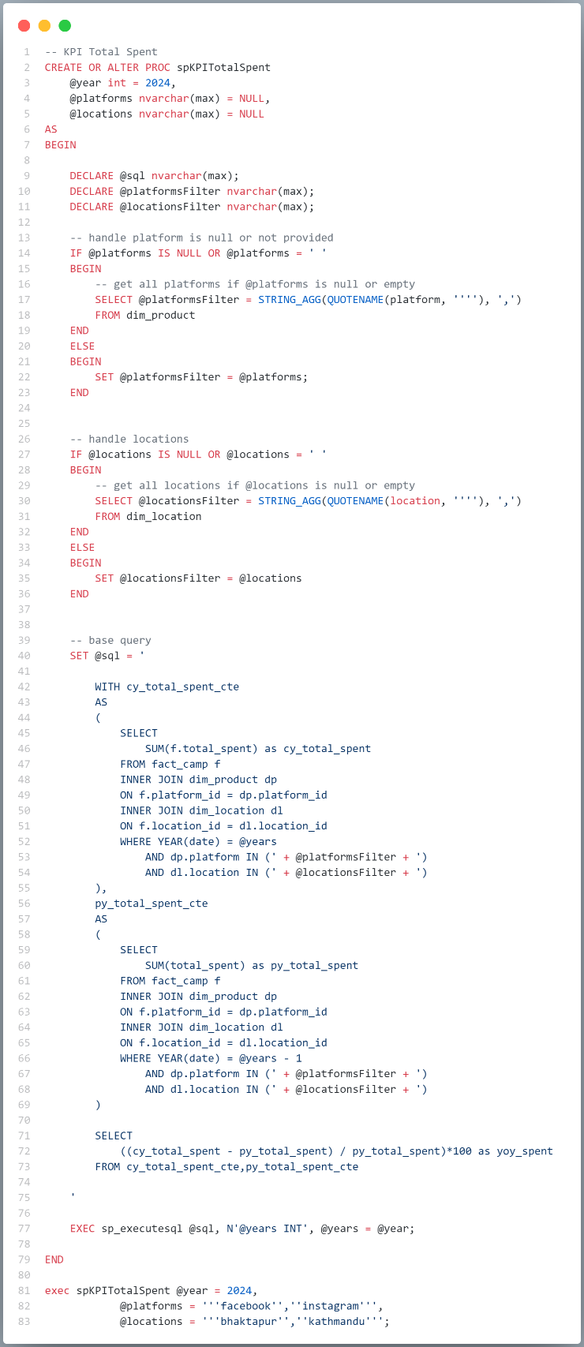



2. KPI Average Cost Per Click

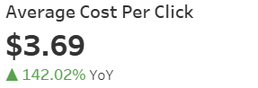

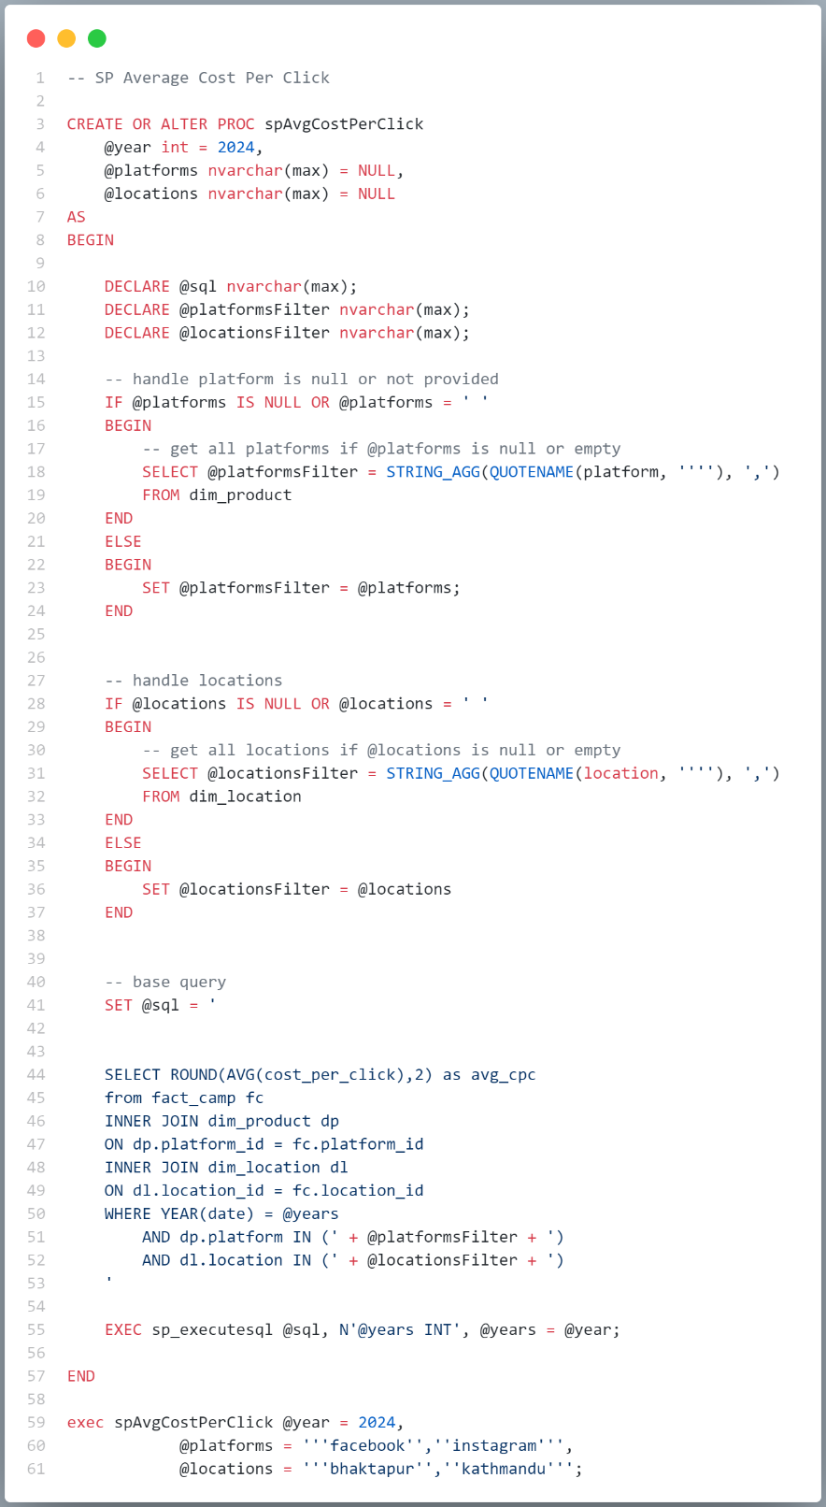



Avg Cost Per Click YoY

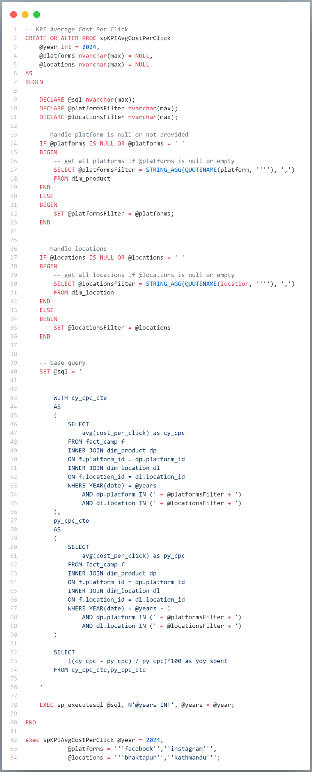  


**3. KPI Average Conversion Rate**

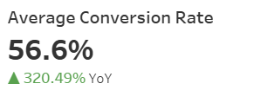

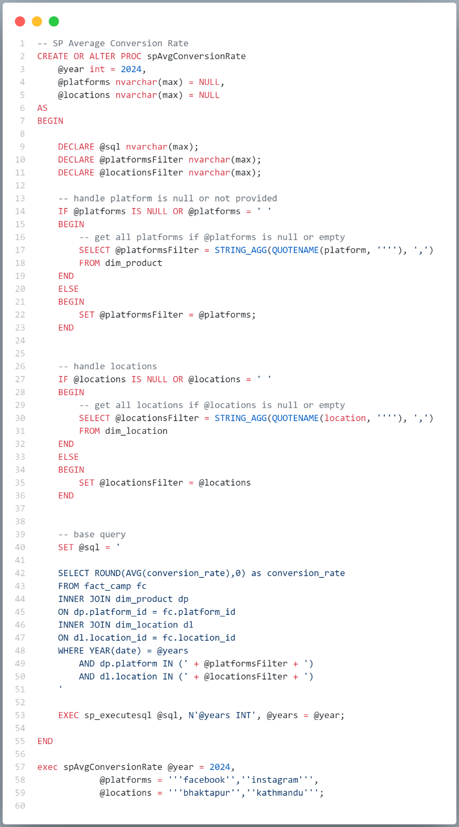



KPI Conversion Rate YoY

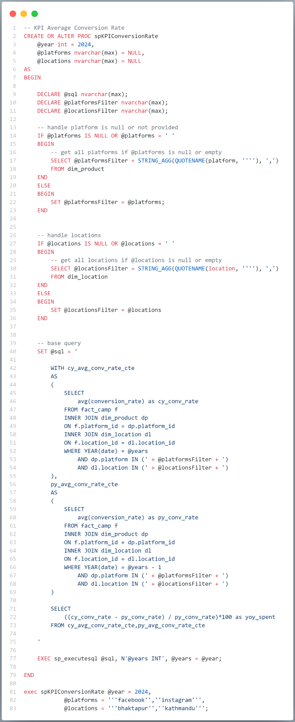



**4. KPI Total Impression**

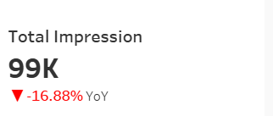

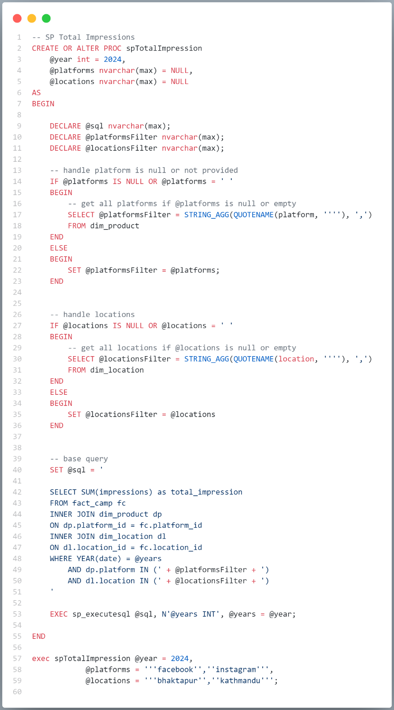



KPI impression YoY

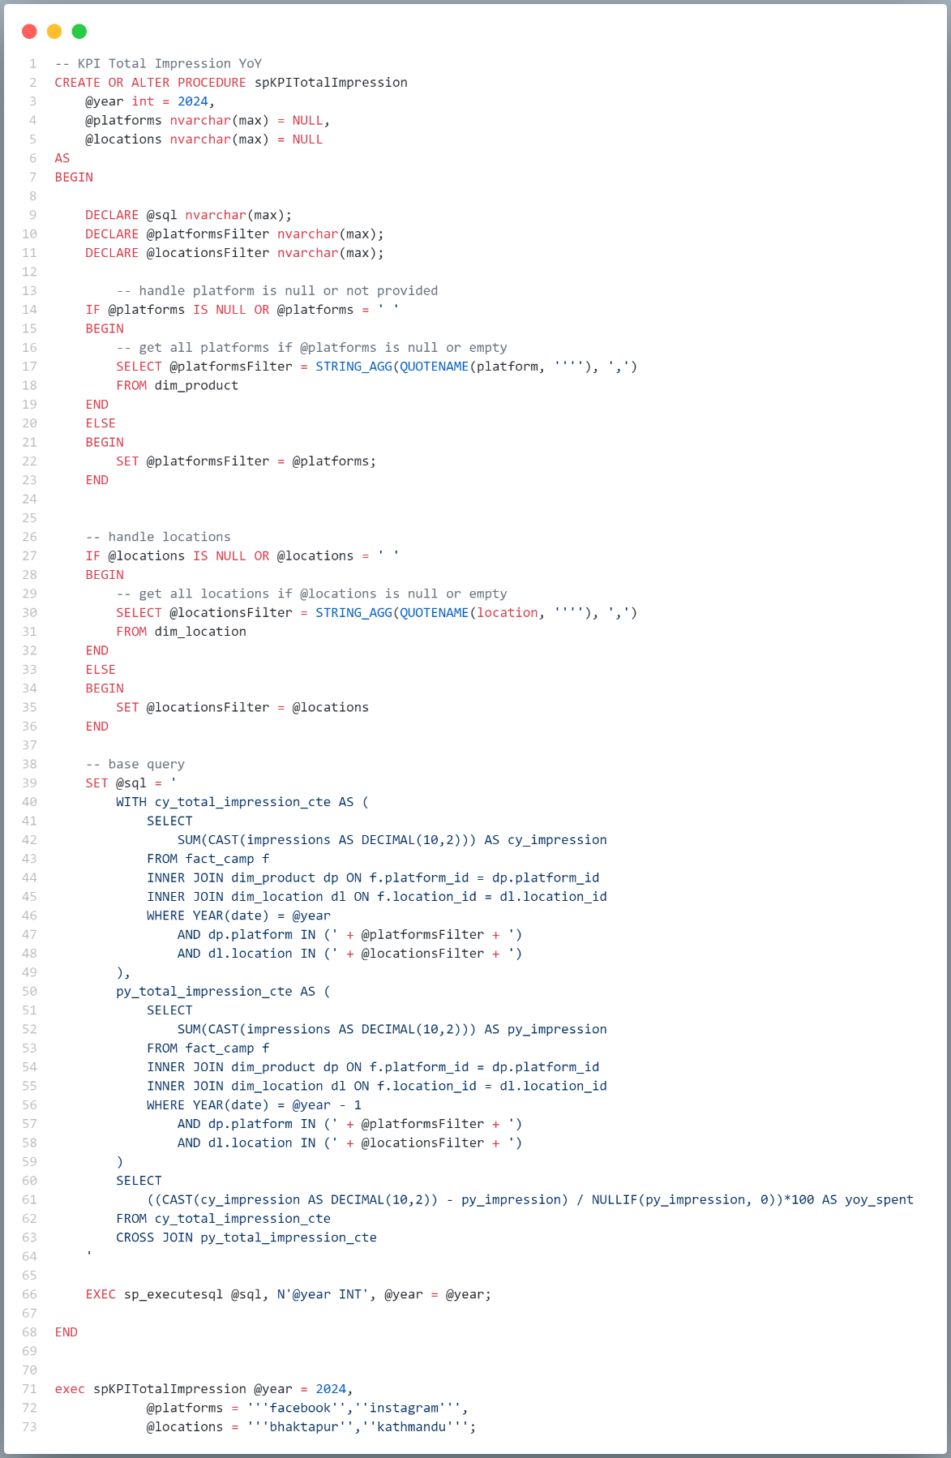



### Line Chart avg cpc over month of particular selected year

